a)

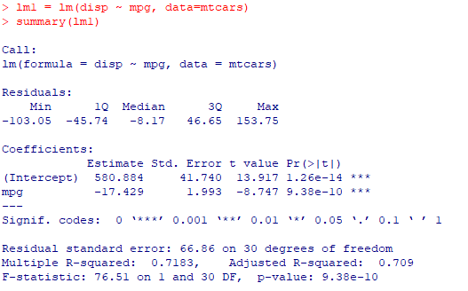

So, our fitted model is

$$disp=580.884-17.429*mpg$$

b) As we can read from our linear model summary output, the $R^{2}$ value from this linear model is 0.7183. So, our model explains 71.83% of the variability in the response; in other words, mpg explains 71.83% of the variability in disp.

c) SSE = (Resid. Std. Error)^2 \* (n – 2) = 66.86^2 \* 30 = 134107.8.

SST = SSE / (1 – R^2) = 134107.8 / (1 - .7183) = 476066

SSR = SST – SSE = 476066 - 134107.8 = 341958.2.